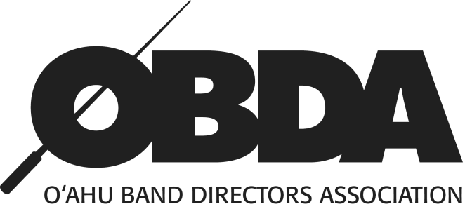
2019 Middle School Honor Band West
Order Form
Student Name:__________________________________________________________________
School:__________________________________ Instrument:__________________________
ITEM | QUANTITY | EACH | AMT. ENCLOSED
Required Participation Fee  (includes performance T-shirt, and digital photo download) | 1 | $15.00 | $15.00
Audio Recording (Complementary) |  |  | Your band director will be emailed the download link shortly after the concert.
Concert Tickets |  | $5.00
TOTAL
All payments are due to the event chair by: FRIDAY, March 1st, 2019.
MIDDLE SCHOOL HONOR BAND WEST
Mr. Daniel Toyooka-Lim
Highlands Intermediate School
1460 Hoolaulea St.
Pearl City, HI 96782
Please make checks payable to:
OAHU BAND DIRECTORS ASSOCIATION

