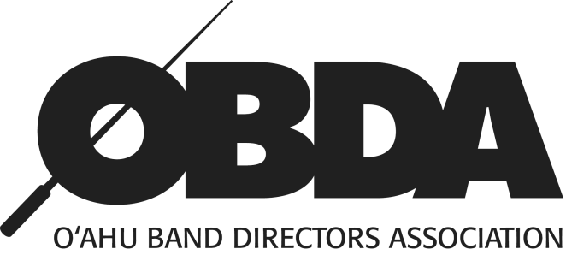
2019 Middle School
Beginning Honor Band West
Order Form
Student Name: _________________________________________________________________
School:__________________________________ Instrument:__________________________
ITEM | QUANTITY | EACH | AMT. ENCLOSED
Required Participation Fee  (includes performance T-shirt, and digital photo download) | 1 | $15.00 | $15.00
Audio Recording (Complementary) |  |  | Your band director will be emailed the download link shortly after the concert.
Concert Tickets |  | $5.00
TOTAL
All payments are due to the event chair by: Friday, March 1, 2019.
MIDDLE SCHOOL BEGINNING HONOR BAND - WEST
Tori Kawasaki
Ilima Intermediate School Music Department
91-884 Fort Weaver Rd
Ewa Beach, HI 96706

Please make checks payable to: OAHU BAND DIRECTORS ASSOCIATION

